Project Design Phase-II
Technology Stack (Architecture & Stack)
Date
Team ID
Project Name | Automated Network Request Management in ServiceNow
Maximum Marks | 4 Marks
Technical Architecture:
The deliverable includes the architectural diagram below along with the component and characteristic details in Table-1 and Table-2.
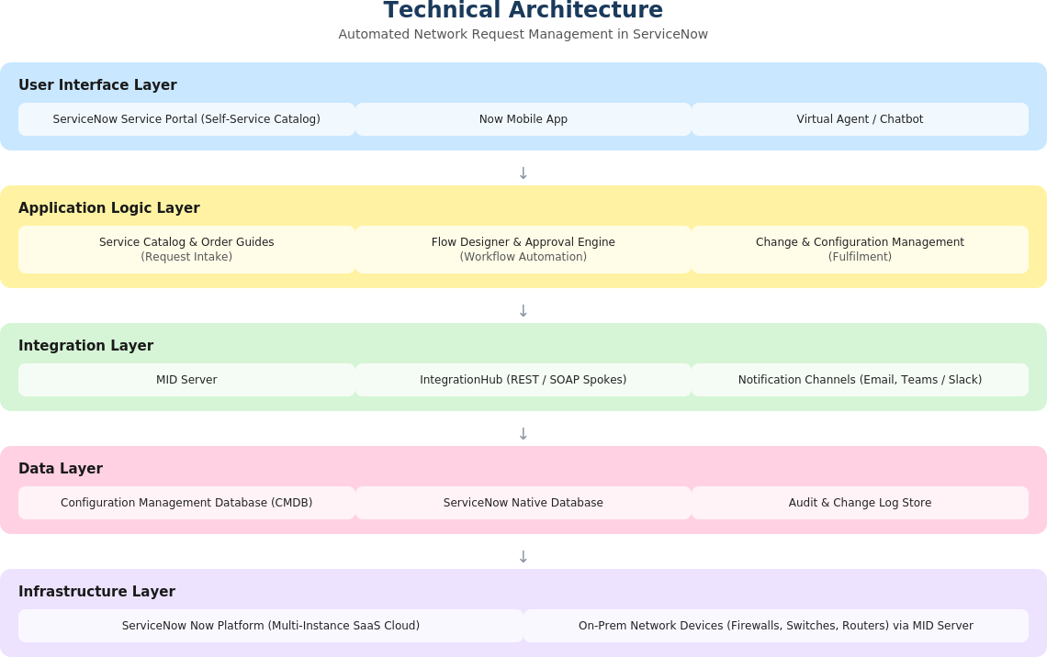
Figure 1: Technical architecture — Automated Network Request Management in ServiceNow
Table-1: Components & Technologies
S.No | Component | Description | Technology
1. | User Interface | How the requester and approvers interact with the system | ServiceNow Service Portal, Now Mobile App, Virtual Agent
2. | Application Logic-1 | Request intake and catalog management | ServiceNow Service Catalog, Order Guides, Glide Script
3. | Application Logic-2 | Approval workflow and routing automation | ServiceNow Flow Designer, Approval Engine
4. | Application Logic-3 | Change and configuration management | ServiceNow Change Management, CMDB (CSDM)
5. | Database | Platform data storage and configuration | ServiceNow native database
6. | Cloud Database | Database service on cloud | ServiceNow multi-instance cloud database
7. | File Storage | Storage for attachments (diagrams, approvals) | ServiceNow Attachment API / Now Platform storage
8. | External API-1 | Provisioning on network devices | REST APIs to firewall / switch / router management systems via MID Server
9. | External API-2 | Notifications to requesters and approvers | Email (SMTP), Microsoft Teams / Slack via IntegrationHub spokes
10. | Machine Learning Model | Risk scoring for change requests | ServiceNow Predictive Intelligence
11. | Infrastructure (Server / Cloud) | Application deployment | ServiceNow Now Platform SaaS instance; on-prem MID Server for network integration
Table-2: Application Characteristics
Characteristics | Description | Technology
Open-Source Frameworks | Front-end frameworks used within the Service Portal | AngularJS, Bootstrap
Security Implementations | Access controls and data protection measures | Role-based ACLs, OAuth 2.0, TLS 1.2+, encryption at rest
Scalable Architecture | Multi-tenant SaaS architecture with modular workflows | ServiceNow Now Platform (multi-instance SaaS)
Availability | Redundant, load-balanced platform architecture | ServiceNow high-availability architecture, 99.9% SLA
Performance | Caching and asynchronous execution for high request volumes | IntegrationHub caching, Flow Designer asynchronous flows

